School Email  mis.eq.edu.au | All staff and students can access their school email addresses by going to mis.eq.edu.au. School email addresses are _______@eq.edu.au. Passwords cannot be reset at home – please contact our Technical Support team if you have a problem with your password.
JacPlus  www.jacplus.com.au  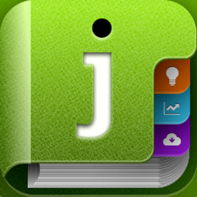 | Students in Years 7-10 have access to the JacPlus platform for online textbooks. Their Username is their school email address, default password is Rochedale (though students may have reset to something personal).
Write That Essay Online Tool  https://www.writethatessay.org/account/login. | All students have access to the Write That Essay Online Tool to practice their writing skills. Student usernames are their school email address and the default password is Rochedale (for first time login only). Please select ‘Forgot my Password’ if students cannot remember their password.
Class Notebook (OneNote)  (link will be emailed by individual teachers, then is accessible via mis.eq.edu.au OneNote)  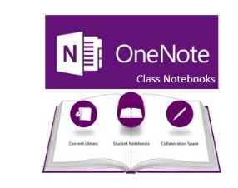 | Class Notebook is a digital notebook uniquely set up for an individual teacher and their class. It provides an online platform for teachers to share content, provide resources and monitor progress for all students in a class. To access, students will initially receive a unique link to join the class. Once that link has been selected once, students will then be able to access their Class Notebook via mis.eq.edu.au, selecting the ‘waffle’ icon in the top left, then selecting OneNote.
Nearpod  www.nearpod.com | Nearpod is a student engagement platform that allows students to explore content and demonstrate understanding through one of the many interactive features, like quizzes, polls, drawing, simulations, VR, collaboration boards and revision games. Students access a Nearpod using a unique Join Code provided by a teacher.
Clickview  www.clickview.com.au | Clickview is a video streaming website that enables safe multimedia content to be shared with students. Clickview videos can also include interactive features, such as multiple choice questions, to ensure active listening. Students can access the platform using their school email address. If they do not know their password, they can select ‘Forgot my Password’ to reset it. Alternatively, teachers may provide a link to a specific video students need to watch.
Blackboard Collaborate  (link will be emailed by individual teachers, access through The Learning Place) | Teachers may opt to use a web conferencing tool to stay in contact with their class. Our school is using Blackboard Collaborate, which is a feature of The Learning Place. If a teacher is going to use this tool with their class, they will email their students with a link to access. The Blackboard Collaborate tool requires a software download to launch – this download will be prompted when you click on the link. Please follow all instructions to install correctly.
QParents  https://qparents.qld.edu.au/ | Parents can stay up to date through the QParents application. Parents will need to register before accessing.
Other Virtual Classrooms, Online Platforms + Digital Resources | Teachers will be using a vast array of other engaging online resources. They will contact parents and students with individual subject requirements and login details.

